SIMATS ENGINEERING (SAVEETHA SCHOOL OF ENGINEERING)
Department of Computer Science and Engineering
CO1 ASSESSMENT TOOL 1 – Case Study Analysis
Course Code: | CSA10 / CSA1063 | Course Title: | Software Engineering
CO Assessed: | CO1 | Assessment: | Assessment Tool 1 – Case Study Analysis
Weightage: | 20% | Total Marks: | 25
CO1 Statement: | Apply advanced methodologies and agile project management techniques to manage software projects effectively
Student Name: | B . Nandini | Reg. No.: | 192525137
Date: | 22-07-2026 | Duration: | 60 minutes

Code of Conduct
I B. Nandini (Name / Reg No) certify that this submission is my original work and that I have adhered to the guidelines specified for this assessment. I understand that any violation of academic integrity rules will result in disciplinary action.
Signature of the Student: B. Nandini

Annexure A – Case Study Analysis

Agriculture equipment rental and farm resource management platform

- Understand the Problem Statement

  - Explain the problem in your own words.
Agriculture is one of the most important sectors, but many farmers face difficulties in accessing modern farming equipment due to its high purchase cost. They also struggle to manage farm resources such as labour, seeds, fertilizers, water, and machinery efficiently because these activities are often handled manually. This results in increased farming costs, delays in agricultural operations, and lower productivity. An Agriculture Equipment Rental and Farm Resource Management Platform provides a digital solution that allows farmers to rent equipment and manage farm resources efficiently through a single online system.
  - Identify the objectives of the proposed system.
- To provide an online platform for renting agricultural equipment at affordable prices.
- To enable equipment owners to list and manage their machinery for rental.
- To simplify the booking, scheduling, and payment process for farm equipment.
- To manage farm resources such as labor, seeds, fertilizers, and water efficiently.
- To maintain digital records of equipment usage, crop activities, and farm operations.
- To reduce farming costs and improve resource utilization.
  - State the scope of the problem.
The proposed system covers the complete process of agricultural equipment rental and farm resource management. It enables farmers to search, book, and rent farming equipment while allowing equipment owners to manage their machinery and rental schedules. The system also supports resource planning, inventory management, payment processing, and report generation. In the future, the platform can be enhanced with weather forecasting, crop recommendation systems, GPS tracking, and government subsidy integration.

- Identify Key Stakeholders and Challenges

  - Identify all the stakeholders involved in the system.
The major stakeholders in the system include farmers, equipment owners, administrators, farm workers, payment service providers, agricultural suppliers, government departments, and maintenance service providers. Farmers use the platform to rent agricultural machinery, manage farm resources, and make payments. Equipment owners register their machinery, update availability, approve bookings, and maintain their equipment. The system administrator manages user accounts, equipment listings, bookings, reports, and overall system security. Farm workers perform farming activities and update task progress. Payment service providers ensure secure online transactions, while agricultural suppliers provide farming inputs such as seeds and fertilizers. Government departments may provide agricultural schemes and subsidies, and maintenance providers ensure that rented equipment remains in good working condition.
  - Explain the roles and responsibilities of each stakeholder.
Stakeholder | Roles and Responsibilities
Farmers | Register on the platform, search and rent agricultural equipment, book machinery, manage farm resources, and make rental payments.
Equipment Owners | Register equipment, update availability and rental charges, approve bookings, maintain machinery, and receive payments.
System Administrator | Manage user accounts, verify equipment listings, monitor bookings, resolve issues, maintain the database, and ensure system security.
Farm Workers/Laborers | Perform assigned farming tasks, update work status, and assist in resource utilization.
Payment Service Providers | Process secure online payments, verify transactions, and generate payment confirmations.
Agricultural Suppliers | Supply seeds, fertilizers, pesticides, and other farming inputs when required.
Government/Agricultural Departments | Provide agricultural schemes, subsidies, policy updates, and monitor farming-related information.
Maintenance Service Providers | Inspect, repair, and maintain agricultural equipment to ensure safe and efficient operation.

  - Discuss the major challenges and issues faced by the stakeholders.
Farmers often face financial difficulties in purchasing expensive agricultural machinery and may experience delays in finding available equipment during peak farming seasons. Equipment owners may struggle to manage bookings and equipment maintenance efficiently. Administrators are responsible for maintaining data accuracy, security, and smooth platform operation. Other challenges include limited internet access in rural areas, low digital literacy among farmers, equipment maintenance costs, and ensuring secure online payment processing.
- Analyze the Current Approach

  - Describe the existing system or current process.
In the existing system, farmers usually rent agricultural equipment through local dealers, neighbours, or personal contacts. Most equipment bookings and farm resource management activities are performed manually using paper records or notebooks. There is no centralized digital platform for checking equipment availability, managing resources, or maintaining accurate records. This traditional process consumes more time, increases the chances of errors, and limits the efficient utilization of agricultural resources.
  - Identify its strengths and limitations.

Strengths
- Simple and familiar process.
- No technical knowledge required.
- Direct communication between farmers and owners.

Limitations
- No centralized booking system.
- Poor equipment availability tracking.
- Manual record keeping causes errors.
- Time-consuming process.
- No online payment facility.
  - Analyze the problems or gaps that need to be addressed.
The current approach lacks automation, making it difficult for farmers to quickly locate available equipment and manage farm resources effectively. There is no centralized database to store rental records, resource details, or payment history. Manual operations increase the possibility of human errors, while the absence of online payment and reporting features reduces convenience and efficiency. These gaps highlight the need for a digital platform that can streamline agricultural operations.
- Propose a Suitable Solution Using Software Engineering Principles

  - Design a software-based solution for the given problem.
The proposed Agriculture Equipment Rental and Farm Resource Management Platform is a web-based or mobile application that connects farmers with equipment owners through a centralized digital platform. Farmers can register, search for available machinery, make bookings, complete online payments, and manage farm resources using a single dashboard. Equipment owners can update machinery availability, rental charges, and booking schedules, while administrators monitor users, equipment, and transactions to ensure smooth system operation.

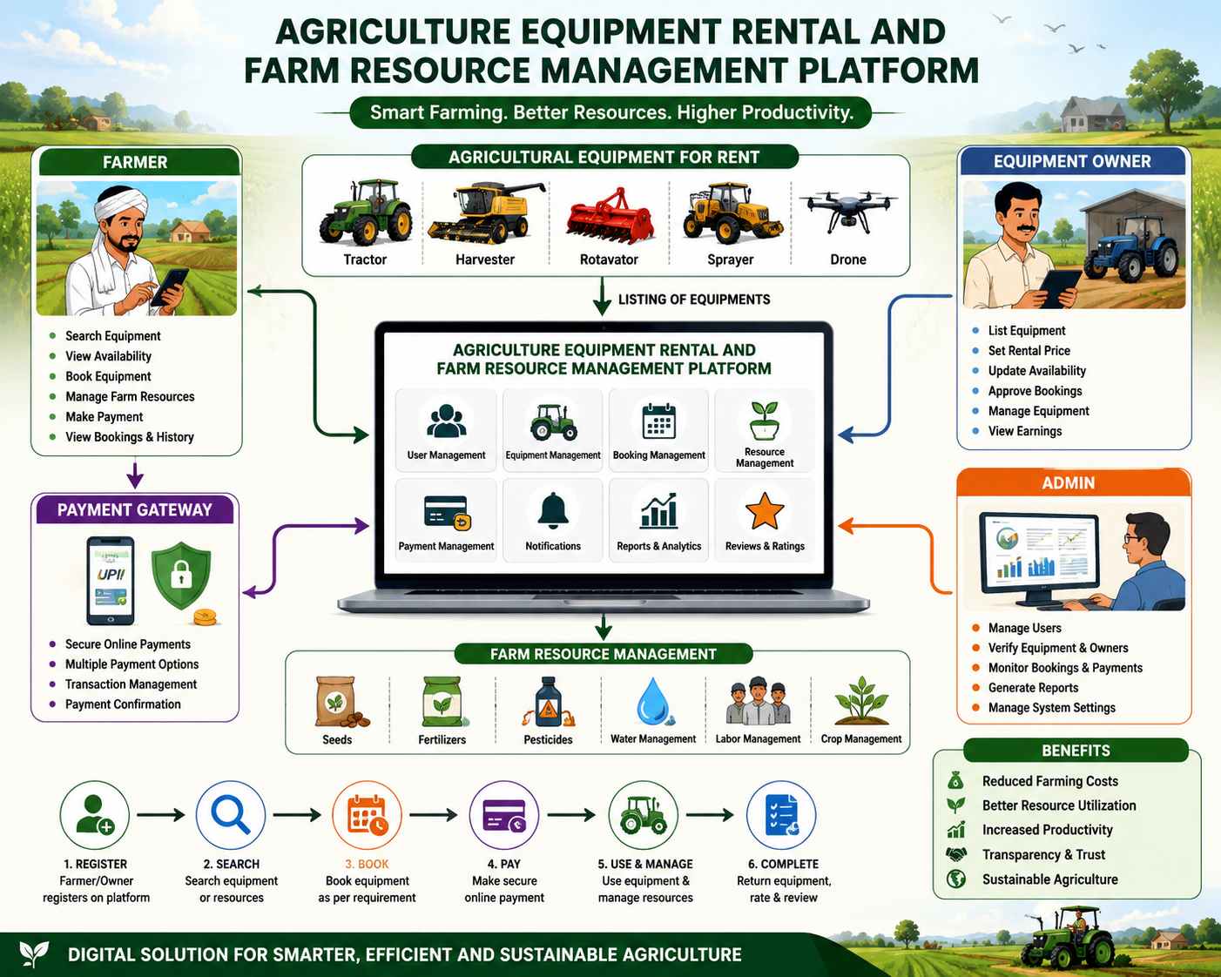

  - Describe the major functional modules of the proposed system.
The proposed system consists of several functional modules, including user registration and login, equipment management, equipment rental and booking, farm resource management, online payment processing, notification services, report generation, and an administrator dashboard. These modules work together to provide an efficient and user-friendly farming management system.
  - Identify the functional and non-functional requirements.

Functional Requirements
- User registration/login
- Search equipment
- Book equipment
- Online payment
- Manage farm resources
- Generate reports
- Booking notifications

Non-Functional Requirements
- Security
- Reliability
- Scalability
- Performance
- Usability
- Availability
- Maintainability
  - Explain how software engineering principles such as modularity, scalability, maintainability, reliability, usability, and security are incorporated into your solution.
The proposed system follows important software engineering principles such as modularity, scalability, maintainability, reliability, usability, and security. Modularity divides the application into independent modules for easier development and maintenance. Scalability allows the system to support a growing number of users and equipment. Maintainability ensures that updates and modifications can be performed easily. Reliability guarantees accurate equipment booking and data management, while usability provides a simple interface suitable for farmers. Security mechanisms protect user information and financial transactions through authentication and encrypted payment processing.

- Justify the Chosen Methodology/Framework

  - Select an appropriate Software Development Life Cycle (SDLC) model or software development framework (e.g., Agile, Scrum, Waterfall, Spiral, DevOps).

The Agile Software Development Life Cycle (SDLC) model is the most suitable methodology for developing this platform because it supports continuous development, testing, and customer feedback throughout the project lifecycle.

  - Justify why the selected methodology/framework is suitable for the proposed system.
Agile allows the development team to build the application in small iterations, making it easier to add new features, fix issues, and respond to changing user requirements. Regular communication between developers and stakeholders improves the quality of the system and ensures that the final product meets the needs of farmers and equipment owners. Agile also enables faster delivery of working software and reduces development risks.
  - Explain how it supports successful project development and maintenance.
The Agile methodology supports successful project development by encouraging teamwork, continuous testing, and regular software updates. Since new requirements can be incorporated at any stage, the system remains flexible and adaptable. Agile also simplifies maintenance by allowing improvements to be implemented without affecting the entire application.
- Discuss Expected Outcomes and Limitations

  - Describe the expected benefits of the proposed solution.
The proposed system is expected to provide affordable access to agricultural equipment, improve the management of farm resources, reduce farming costs, and increase agricultural productivity. Farmers will benefit from a centralized platform for booking machinery, maintaining farm records, and making secure online payments. Equipment owners will also benefit from better equipment utilization and increased rental opportunities.

  - Explain how the solution addresses the identified challenges.
The platform addresses existing challenges by providing an automated and transparent equipment rental process, improving resource planning, reducing manual paperwork, enabling secure online payments, and maintaining accurate digital records. These improvements help farmers complete agricultural activities on time while making better use of available resources.
  - Discuss potential risks, implementation challenges, and limitations.
The proposed Agriculture Equipment Rental and Farm Resource Management Platform may face several risks and implementation challenges. Farmers in rural areas may have limited internet connectivity and lack the digital skills required to use the platform effectively. The system also depends on the availability and proper maintenance of agricultural equipment, which may lead to booking conflicts or delays during peak farming seasons. Ensuring secure online payments, protecting user data, and maintaining system reliability are additional challenges. Furthermore, the platform requires continuous technical support, regular software updates, and active participation from farmers and equipment owners for successful implementation. Although the system improves farming efficiency, its effectiveness may be limited by infrastructure constraints, technology adoption, and the willingness of users to transition from traditional methods to digital solutions.

  - Suggest possible future enhancements.
Although the proposed system offers many advantages, it requires internet connectivity and basic digital literacy among users. Initial development and maintenance costs may also be significant, and equipment availability depends on the participation of equipment owners. Future enhancements may include artificial intelligence for crop recommendations, weather forecasting integration, GPS-based equipment tracking, multilingual support, mobile applications, and integration with government agricultural schemes and subsidies.

Rubrics for Calculation
Criteria | Excellent (5 Marks) | Good (3 Marks) | Satisfactory (2 Marks) | Needs Improvement (1 Mark)
Problem Understanding | Clearly explains the problem, objectives, and scope with complete understanding. | Explains the problem with minor omissions. | Basic understanding with limited explanation. | Poor understanding; objectives and scope are unclear or missing.
Stakeholder & Challenge Analysis | Identifies all stakeholders, their roles, and challenges with clear analysis. | Identifies most stakeholders and challenges with adequate analysis. | Identifies only a few stakeholders or challenges. | Stakeholders and system analysis are incomplete or inaccurate.
Current System Analysis | Thoroughly analyzes the existing system, strengths, weaknesses, and identifies all gaps. | Good analysis with most strengths and weaknesses identified. | Limited analysis with partial identification of issues. | Proposed solution is unclear or inappropriate; requirements are largely missing.
Proposed Software Solution & Software Engineering Principles | Proposes an innovative, feasible solution applying appropriate software engineering principles (modularity, scalability, maintainability, security, etc.). | Suitable solution with good application of software engineering principles. | Basic solution with limited application of software engineering principles. | Methodology is inappropriate, poorly justified, or not discussed.
Methodology/ Framework Justification | Selects the most suitable SDLC/model/framework and provides strong technical justification. | Suitable methodology selected with adequate justification. | Methodology selected but justification is weak. | Outcomes, limitations, or future enhancements are missing; report lacks organization and clarity.

Criteria | Mark
Problem Understanding | /5
Stakeholder & Challenge Analysis | /5
Current System Analysis | /5
Proposed Software Solution & Software Engineering Principles | /5
Methodology/ Framework Justification | /5
TOTAL | /5

